

OA-OIT Service Catalog
Office of Administration – Office for Information Technology

Version 1.2 – March, 2016

Table of Contents

Infrastructure as a Service (IaaS)
Co-Location 4
Managed Services 5
Managed Services Lite 7

Platform as a Service (PaaS)
Enterprise Business Intelligence Suite (Business Objects) 9
Enterprise Messaging 10
Enterprise Portal 11
SAP Learning Solution –LSO 12
SharePoint Online 13
SharePoint 2013 On-Premises Shared Service 14
Virtual Desktop Services 15

Professional Services
Desktop Support 16
Enterprise Services and Contractual Management 17
IES Business Application Services 18
LAN Support 19
Web Site or Content Development 20
Web Site Support 21

Security Services
Blue Coat Reporting and Troubleshooting 22
Computer Forensics Investigations 23
Identity and Access Management 24
Security Assessment 25
Security Information & Event Management (SIEM) 26
Social Engineering Security Awareness Training 27
Vulnerability Management 28
Web Application Firewall 29

Software as a Service (SaaS)
Address Verification 30
Alerting and Notifications 31
Application Development 32
Application Support 33
ArcGIS Desktop Tools 34
County Offender Query (ER Query) 35
Court Case Event Messages 36
Daptiv Project Portfolio Management 37
Enterprise Mobile Management Services 38
Geocoding 39
GIS Data Hosting 40
GIS Metadata 41
Information Technology Service Management (ITSM) Tool 42
JEMS – DHS Child Support Warrant 44
MyEvents2Go 45
Notification Web Service 46
OneDrive for Business (OD4B) 47
PA Map Gallery 48
Photo Search – Federated 49
TomTom Tools 50
Web Map Creation 51
Web Map Hosting 52

Appendix 53

Revision History 53

This document describes the services offered by the Office of Administration – Office for Information Technology to commonwealth departments, boards, commissions and councils under the Governor’s jurisdiction.

This service catalog is for informational purposes and does not constitute a contract.

Planned outages are scheduled in compliance with IT Policy SYM010 – Enterprise Services Maintenance Scheduling.

Infrastructure as a Service

Co-Location



Service Description

Provides a secure datacenter environment for agencies to deploy servers. The Enterprise Data Center provides server rack space, power, network connectivity and physical and network security services in a conditioned facility. The agency is responsible for complete server administration and application management.

What is Included

- Business Layer Logic.
- ePay Services.
- Firewall Services.
- Hardware Load Balancing.
- Microsoft Active Directory.
- Name Resolution Services.
- Network Management.
- PALogin Services Keystone ID.
- Remote KVM Access.
- Security Services.
- Web Hosting.

The Enterprise Data Center provides Technology Service Offerings that address the majority of agency requests for consistent high-quality services. The Enterprise Data Center has standardized specific technical service offerings to ensure consistency in deployment and support.

Service Levels

Availability Service Level Objective:
- Target 99% uptime.

Service Activation Service Level Objective:
- Standard Service Deployment is 1 – 2 weeks upon acceptance of the Solution Proposal.

Response Time Service Level Objective:
- Urgent – Critical Production Application is down or Service unavailable – Immediate.
- High – Connectivity issues or Performance issues – 1 business day.
- Medium – Request for service or Request for deployment – 2 to 5 business days.
- Low – Questions or Informational request – 6 to 10 business days.

Additional Information

Enterprise Data Center reference documents which provides more in depth details of this service are available at www.esfportal.state.pa.us.

Infrastructure as a Service

Managed Services



Service Description

Provides agencies full application hosting services, which includes application support, monitoring and a structured deployment methodology at the Enterprise Data Center. This environment allows agencies to leverage shared infrastructure to reduce overall hosting cost.

What is Included

• Backup and Restoration.
• BizTalk Services.
• Business Objects (Crystal Reports).
• Commerce Services.
• Database Design Services.
• ePay Services.
• Enterprise Data Center File Transfer Services.
• Firewall Services.
• Hardware Load Balancing.
• Microsoft SQL.
• Name Resolution Services.
• Network Management.
• Oracle.
• PALogin Services.
• Patch Management.
• Real-Time Monitoring.
• Search Services.
• Security Services.
• SiteMinder.
• SMTP Relay.
• Storage Area Network (SAN).
• VMWare Infrastructure Client.
• Web Proxy Services.
• Web Statistics Reporting.
• Web Hosting.
• Websphere MQ.

The Enterprise Data Center provides Technology Service Offerings that address the majority of agency requests for consistent high-quality services. The Enterprise Data Center has standardized specific technical service offerings to ensure consistency in deployment and support.

Service Levels

Availability Service Level Objective:
- Target 99% uptime.

Service Activation Service Level Objective:
- Standard Service Deployment is 1 – 2 weeks.

Response Time Service Level Objective:
- Urgent – Critical Production Application is down or Service unavailable – Immediate.
- High – Connectivity issues or Performance issues – 1 business day.
- Medium – Request for service or Request for deployment – 2 to 5 business days.
- Low – Questions or Informational request – 6 to 10 business days.

Additional Information

Enterprise Data Center reference documents which provides more in depth details of this service are available at www.esfportal.state.pa.us.

Infrastructure as a Service

Managed Services Lite

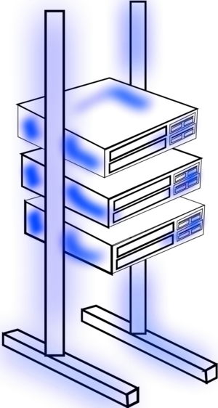

Service Description

Provides a secure datacenter environment for agencies to deploy services. The Enterprise Data Center provides server rack space, power, network connectivity, physical and network security services, server backup and administration, in a conditioned facility. The agency is responsible for application management.

What is Included

Standard features of this service are:
- Virtual and Physical server hosting.
- Backup and Recovery.
- Virtual and Physical Server Software Licensing.
- Operational Support of the virtual server.
- Operational Support of the physical server.
- Enterprise Storage Area Network (SAN) environment.
- Implementation Services.
- Microsoft Premier Support for infrastructure support.
- DNS – Domain Name Services.
- SMTP – Outbound mail services.
- Hardware Load Balancing.
- Firewall services.
- Anti-Virus and HIPS support.
- Operating system Patch Management.
- Add-on components are customized to meet the unique needs of the application and include:
- Backup Capacity for additional storage.
- Digital Certificates (SSL).

Optional features of this service are:
- CA SiteMinder – Single Sign-on.
- Active Directory – Directory Services.
- WebSphere MQ – Data Exchange.
- Database Administration – SQL and Oracle.
- ePay – Electronic Payment Web Service.
- Find additional details about these features on EDC Portal.

Service Levels

Availability Service Level Objective:
- Target 99% uptime.
Service Activation Service Level Objective:
- Standard Service Deployment is 1 – 2 weeks.

Response Time Service Level Objective:
- Urgent – Critical Production Application is down or Service unavailable – Immediate.
- High – Connectivity issues or Performance issues – 1 business day.
- Medium – Request for service or Request for deployment – 2 to 5 business days.
- Low – Questions or Informational request – 6 to 10 business days.

Additional Information

Enterprise Data Center reference documents which provides more in depth details of this service are available at www.esfportal.state.pa.us.

Platform as a Service

Enterprise Business Intelligence Suite (Business Objects)



Service Description

Shared Service Offering provides all agencies with a business intelligence application to create reports and dashboards by bringing together data from multiple systems.

What is Included

- Provides software licenses for both Centralized Business Objects Enterprise and De-centralized BOE.
- Provides a fully-managed Centralized Business Objects Enterprise server environment with software version controls, capacity planning, and backups.
- Administers folders, user’s permissions and firewalls.
- Maintains Business Objects developer’s portal and intranet.
- Enables development of both reports and dashboards from defined “universe of data”.

Optional features of this service are:
- Development by Integrated Enterprise System (IES) of a “universe of data” built from agency specific SAP data.
- Assist in agency development of reports and/or dashboards using the agency specific “SAP universe of data”.
- Development by OA of a “universe of data” built from agency specific data but does not include SAP data.
- Assist in agency development of reports and/or dashboards using the agency specific “OA universe of data”.
- Training can be scheduled for agency developers in SAP Learning Solution (LSO).

Service Levels

Availability Service Level Objective:
- Target 99% uptime.

Additional Information

Contact RA-businessobjects@pa.gov for additional information about this service.
The components that make up the EQRA package (Enterprise Query, Reporting, and Analysis) are the following:
- Business Objects Enterprise Premium.
- Business Objects Xcelsius Enterprise Interactive Viewing.
- Business Objects Live Office
- Xcelsius Enterprise.
- Crystal Reports – Desktop Developer.
- Publisher.
- Web Intelligence/Rich Client.
- Business Objects Voyage.

Platform as a Service

Enterprise Messaging


Service Description

Provides a consistent, reliable, and secure platform for communication, collaboration and desktop/laptop computing for commonwealth agencies under the Governor’s jurisdiction. Common services include Active Directory, MS Exchange, Secure Containerized email for mobile devices, and Message Hygiene.

What is Included

- Active Directory integration.
- Microsoft Exchange (email).
- Outlook Web Access.
- Secure Containerized email for mobile devices.
- Email encryption.
- Anti-spam.

Service Levels

Availability Service Level Objective:
- Target 99% uptime.

Additional Information

Enterprise Messaging reference documents which provides more in depth details of this service are available at www.esfportal.state.pa.us.

Platform as a Service

Enterprise Portal

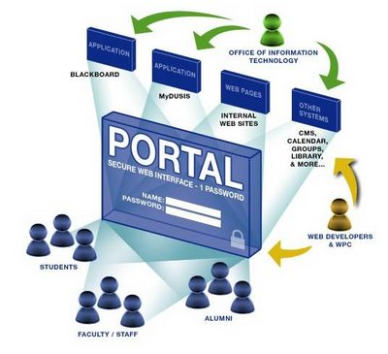

Service Description

Maintain and manage the technology platform used by government agencies host secured and unsecured web sites until portal decommissioning at the end of calendar year 2016.

What is Included

- Administration of portlet code repository.
- Maintenance of the enterprise search index.
- Provide help desk services.
- Provide on-going maintenance and capacity monitoring for high availability.

Service Levels

Agreed upon uptime between business owner and the Enterprise Portal Team.

Additional Information

Reference documents which provide more in depth details of this service are available at www.portal.state.pa.us.

Platform as a Service

SAP Learning Solution – LSO

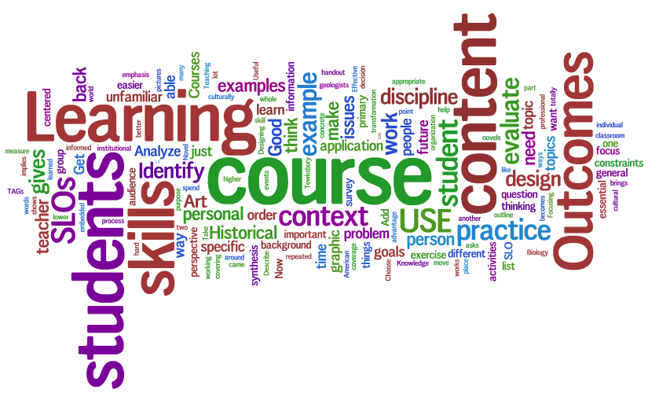

Service Description

The SAP Learning Solution – LSO is a comprehensive learning management system.

What is Included

- Standard SAP Learning Solution – LSO functionality – Agency and enterprise training catalogs, search capability, course registration, curriculum management, participation management, reporting, transcripts, web based training delivery, on-line evaluations, on-line tests, and multiple administrator roles.

Service Levels

None

Additional Information

To request hands on training contact - ra-lsoadministrator@pa.gov

Use the following links to download procedural desk references:
Learners – Supervisors – Instructors - Reporters Administrators

Learner, supervisor and reporter Web based training can be found in the SAP Learning Solution – LSO catalog at, OA sponsored trainings for all agencies.

Platform as a Service

SharePoint Online



Service Description

SharePoint Online is a cloud-based service that helps organizations share and collaborate with colleagues, partners, and customers. With SharePoint Online, you can access internal sites, documents, and other information from anywhere – at the office, at home, or from a mobile device.

What is Included

- Sites – Allows for the creation of customized sub-sites under a given SharePoint site. Sites may be targeted to a particular department of an organization or a particular user group or subject matter.
- Communities – Allows users to share knowledge and information with each other and may involve activities such as: information sharing, knowledge sharing, content tagging, user feedback and more.
- Content – SharePoint Online is a collection of web-based tools and technologies that help store, share, and manage digital information. The hosted service is ideal for working on projects, storing data and documents in a central location, and sharing information with others.
- Search – Allows users to search for content, documents, images or people within a SharePoint site with a power search engine.
- Insights – Enables native integration with other Microsoft products and services such as: Excel Services, Visio, PowerPivot, SQL Server and Reporting services.
- Composites – Enables the development of customized solutions by integrating existing pieces of applications developed separately. These may be external software or external data connectivity.

Service Levels

Service level objectives are based on priority, defined by impact and urgency.

Additional Information

Information and documentation regarding the shared service is available at SP Central.

Platform as a Service

SharePoint 2013 On-Premises Shared Service

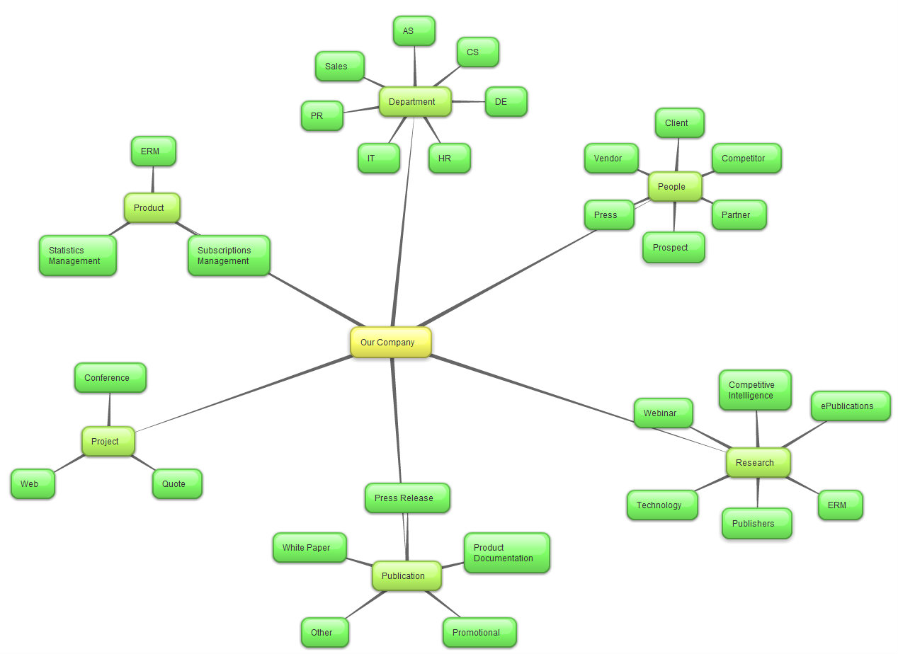

Service Description

This enterprise service will support Standard and Enterprise versions of SharePoint.

What is Included

Sites – Allows for the creation of
Service Features are based on the version of SharePoint agencies are interested in leveraging. Agencies are responsible for procuring the necessary end user Client Access Licenses that are needed to leverage the service & will need to provide copies of Client Access License Purchase Orders to the Office for Information Technology.

Standard Features:
- Intranet and Extranet Service.
- Internet secured access to SharePoint for authenticated users (CWOPA, USER, MUSER domains).
- SharePoint Production, Staging and Development environments.
- Service platform (hardware/software) life cycle management (i.e., capacity, upgrades, patches, etc).
- Support for troubleshooting infrastructure, security, and site collection administration issues.
- Tier 2 and Tier 3 SharePoint help desk support during normal business hours (8am to 5pm) Monday thru Friday.
- 24x7 infrastructure support with scheduled maintenance.
- Infrastructure recovery within 24 hours.
- Daily database backups.
- Change Advisory Board consisting of the Bureau of Application Management Services, Enterprise Technology Services Office, and agency site collection administrators.

Service Levels

Service level objectives are based on priority, defined by impact and urgency.

Additional Information

Information and documentation regarding the shared service is available at SP Central.

Platform as a Service

Virtual Desktop Services


Service Description

This Service delivers a virtualized Windows Desktop that resides in the data center that can be accessed by an end user device from within the COPA network or remote. Operating systems that are supported for connecting to the virtual desktops include Microsoft Windows, Apple Macintosh OSX, Apple IOS (iPad/iPhone), and Android.

What is Included

- Setup of environment for Agency IT staff to build, deploy, and manage a custom desktop image for deployment to agency end users.
- Guidance for recommended configurations based on use cases for targeted users.
- Administrator training for administering the desktops from a deployment and operational support perspective.
- Documentation for a standard user deployment and configuration of end user devices for connecting to their assigned virtual desktops.
- Tier2 support for agency administrators for troubleshooting and deployment assistance.

Service Levels

Describes the level of service expected between the service provider and customer, documenting service level targets and the responsibilities of the service provider and the customer. This can include contractual Service Level Agreements, non-contractual Service Level Objectives or Operational Level Agreements.

Additional Information

A start-up and deployment guide will be provided to all agency VDI administrators to assist with implementing and deploying their virtual desktops.

Sample end user training (documentation and videos) will also be provided that the agency can use.

Professional Services

Desktop Support



Service Description

Delivers support of employee personal computing hardware and software systems.

What is Included

- Setup for new employees and contractors.
- Obtain quote of hardware and software for Agency purchase.
- Installation and configuration of equipment including laptop, workstation, printer, and peripheral devices.
- Installation and configuration of software which run on the desktop.
- Provides scheduled software maintenance patching.
- Troubleshooting of hardware and software.
- Upgrade, replacement and disposal of all desktop equipment.
- Asset management of desktop equipment and software.

Service Levels

Installation and Configuration Completion Service Level Objective:
- Target: Schedule/respond within 5 business days of the request.
- Target: Completion is within 20 days.
- Large scale installations are exempt.

Resolve Time Service Level Objective:
- Target: 60% of all reported Break/Fix issues resolved within 1 business day.

Response Time Service Level Objective:
- Urgent – Business-critical production outage impacting multiple people – 15 minutes.
- High – Non-business-critical process impacting multiple people – 1 hour.
- Medium – Request for service – 8 hours.
- Low – Questions or informational requests – 16 hours.

Additional Information

None

Professional Services

Enterprise Services and Contractual Management
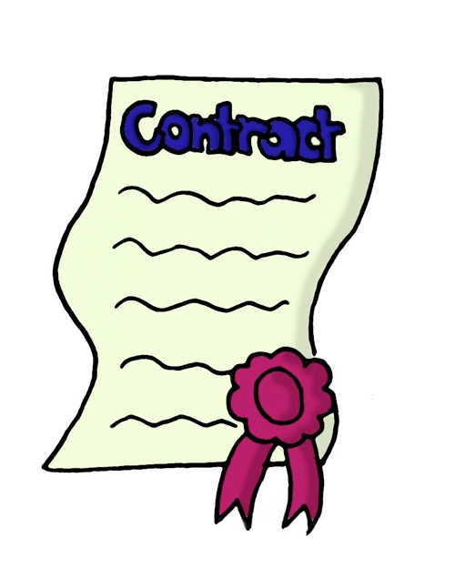
Service Description

Provides administrative services to agencies supporting enterprise IT contracts and technology services.

What is Included

- Offers technical assistance and training for Enterprise Services Management System.
- Provide advocacy services to agencies for ordering, billing and inventory discrepancies and issues.
- Facilitate Request Fulfillment Process for enterprise IT services.
- Assistance in dispute resolution related to orders or delivery of service.
- Administer enterprise license agreements by managing renewals, license counts and cost allocations.
- Manage Service Levels to improve the level and ensure the quality of service delivered.

Service Levels

None

Additional Information

None

Professional Services

IES Business Application Services


Service Description

Implements and supports the business applications that are used by the Commonwealth’s central business process owners, primarily running in the SAP environment.

What is Included

The following functions are available in the IES ERP environment:
- Finance – Controlling (FI-CO)
- Financial Management (FM – Budget)
- Procurement / Supplier Relationship Management (PROC / SRM) (includes Live Auction)
- Plant Maintenance (PM)
- Human Resources (HR)
- Payroll (PY)
- Travel Expenses
- RWD uPerform (CoPa Custom Help, Training Documentation, EUP’s, Simulations, etc)

Service Levels

The contractual SLA with the technical environment provider for system availability to end users is 99%.

Additional Information

Customers should contact Robyne Lyons at roblyons@pa.gov for other information.

Professional Services

LAN Support

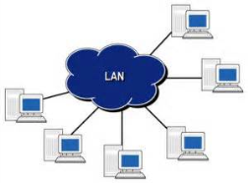

Service Description

Delivers configuration, setup and on-going maintenance of Local Area Network (LAN) to provide connectivity for local computing and printing resources within a building or campus environment.

What is Included

- Network administration to include Local Area Network switches, firewalls, routers, Internet content filters, and Dynamic Host Configuration Protocol services.
- Server administration to include installation and configuration of server hardware and software in support of all File and Print functions and network infrastructure.
System administration to include patching, software packaging and distribution, and system configuration reporting.
Note: This service is only available to the Office of Administration and the consolidated agencies:
- Budget
- Emergency Management
- General Counsel
- General Services
- Governor’s Office
- Historical and Museum Commission
- Human Relations Commission
- State Police
- State
- State Tax Equalization Board

Service Levels

Availability Service Level Objective:
- Target: 99.5% uptime during business hours of 7:30 AM to 5:00 PM.

Response Time Service Level Objective:
- Urgent – Business-critical production outage impacting multiple people – 15 minutes.
- High – Non-business-critical process impacting multiple people – 1 hour.
- Medium – Request for service – 8 hours.
- Low – Questions or informational requests – 16 hours.

Additional Information

None

Professional Services

Web Site or Content Development



Service Description

Delivers web site maintenance and support that meet specific customer requirements.

What is Included

- Provide web site conversion options.
- Ensure adequate portal security measures are followed.
- Provide documentation options.
- Provide ongoing maintenance and support.

Service Levels

Agreed upon uptime between the business owner and development team.

Additional Information

None

Professional Services

Web Site Support



Service Description

Delivers web site support solutions that meet specific customer requirements.

What is Included

- Provides a process for updating, maintaining and modifying an existing supported web site.
- Work with business analyst, project manager or end user to gather requirements.
- Provide system coding as needed.
- Ensure adequate portal security measures are followed.
- Ensure commonwealth standards are followed.
- Plan and coordinate web site modifications with the business owner.

Service Levels

Agreed upon uptime between the business owner and development team.

Additional Information

None

Security Services

Blue Coat Reporting and Troubleshooting


Service Description

Delivers reports, analyze and assess an agency’s internet usage.

What is Included

- Create enterprise level Blue Coat Compliance Reports and provide RA-Investigations@pa.gov with internet usage reports.
- Help the Agency read and interpret reports that Enterprise Information Security Office provides to the Agency.
- Help the Agency troubleshoot report issues and develop reports to suit the needs of the Agency.

Service Levels

None

Additional Information

Reference documents which provides more in depth details of this service are available at www.cybersecurity.state.pa.us.

Security Services

Computer Forensics Investigations


Service Description

Delivers comprehensive investigation and analysis of service outage or compromised or breach data incidents.

What is Included

- Provides systematic inspection of commonwealth systems and their contents for evidence or supportive evidence of cyber crimes or other computer use that is being inspected.
- Collects and analyzes evidence in a fashion that adheres to standards of evidence that are admissible in a court of law.
- Identifies the cause of incident.
- Contains compromised service.
- Identifies policy violation.
- Recommends appropriate repair of discovered vulnerabilities.
- Performs scanning and evaluation after repair of device.

Service Levels

None

Additional Information

Reference documents which provides more in depth details of this service are available at www.cybersecurity.state.pa.us.

Security Services

Identity and Access Management



Service Description

Delivers SSO and management of employee and contractor accounts in CWOPA and Exchange.

What is Included

Standard features of this service are:
- Single Sign On (SSO) using the CA Siteminder product at the enterprise portal as well as the Integrated Enterprise System (IES) (HR) system.
- Virtual Directory services using the Radiant Logic virtual directory.
- Automated management of employee and contractor accounts in CWOPA Active Directory along with the corresponding Exchange accounts (using IBM Security Identity Manager).
- Manual provisioning of Service, Resource, and Test accounts in CWOPA using Security Identity Manager.

Optional features of this service are:
- Self-service password reset functionality using Security Identity Manager.

Service Levels

None

Additional Information

Reference documents which provides more in depth details of this service are available at
Siteminder
Security Identity Manager.

Security Services

Security Assessment



Service Description

Delivers consulting services to analyze and assess an agency’s security posture.

What is Included

- Conducts interview, inspections, assessments and policy reviews.
- Identify, quantify, and prioritized vulnerabilities in a system and infrastructure.
- Assures compliance with key security, physical, device, network, human, and policy controls.
- Details discovered risks and provide risk mitigation options for remediation in a written report.
- Offers review and guidance on policy and procedure development.
- Performs annual extensive audits and quarterly full audits.
- Performs application and host based security scans in response to CA2 requests.

Service Levels

None

Additional Information

Reference documents which provides more in depth details of this service are available at www.cybersecurity.state.pa.us.

Security Services

Security Information & Event Management (SIEM)



Service Description

Delivers log consolidation services to aggregate and correlate security-relevant data for in-depth threat analysis.

What is Included

- Offers collection, monitoring, and auditing of logs from all critical enterprise assets residing on the network.
- Provides security compliance reporting for regulations and internal policies.
- Enhances security with real-time alerting of threats and anomalies.

Service Levels

None

Additional Information

Reference documents which provides more in depth details of this service are available at www.cybersecurity.state.pa.us.

Security Services

Social Engineering Security Awareness Training



Service Description

Ensures that all commonwealth users are familiar with information technology security best practices and policies.

What is Included

- Establish requirements for the correct security posture of employees and contractors that access computer networks.
- Ensure requirements for state and federal regulations are included in training.
- Procure and customize training courses.

Service Levels

None

Additional Information

Reference documents which provides more in depth details of this service are available at www.cybersecurity.state.pa.us.

Security Services

Vulnerability Management

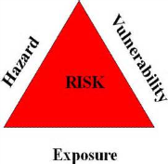

Service Description

Delivers mechanisms to prevent and/or defend against cyber attacks as well as reduce vulnerabilities.

What is Included

- Exam application or network to determine adequacy of security measures with vulnerability scans and testing.
- Deploy and maintain anti-virus software.
- Isolate and remediate infected systems.
- Evaluate the security of a system or network through penetration testing.
- Provide customized reports outlining options for remediation.

Service Levels

None

Additional Information

Reference documents which provides more in depth details of this service are available at www.cybersecurity.state.pa.us.

Security Services

Web Application Firewall

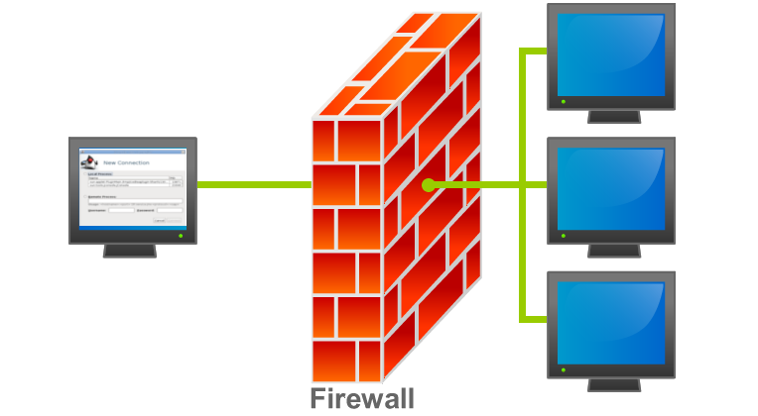

Service Description

Web Application firewalls limits the access to web facing applications located in the Commonwealth’s Enterprise Server Farm’s loadbalaced Web Appliactions Managed Services and Managed Services Light. The reason that application firewalls are needed is to protect the Commonwealth against SQL injections and cross scripting attacks. These attacks are extremely dangerous and can enable attackers to gain access to highly confidential information such as citizen’s names, dates of births, social security numbers, addresses, driver license numbers, etc.

What is Included

- Internet facing critical web applications in the Enterprise Data Center.

Service Levels

None

Additional Information

Reference documents which provides more in depth details of this service are available at www.cybersecurity.pa.gov.

ITP-SEC004 – Enterprise Web Application Firewall, Issued 1/15/10.

Software as a Service

Address Verification



Service Description

Access to web services that clean and verify mailing lists containing street addresses.

What is Included

- Offers a shared service for use by multiple agencies.
- Leverages the OA address verification infrastructure.
- Processes a file containing a single address (one address at a time).
- Processes a batch file that contains multiple addresses.
- Qualifies batch processing of addresses for postal discounts.
- Provides a developer integration guide for integrating applications with the web services.
- Monthly data updates.
- Address Verification Software Updates.
- Maintains 3-5 second web service response time.
- Provides a Graphical User Identification and Password per application.

Service Levels

Availability Service Level Objective:
- Target 99% uptime.

Response Time Service Level Objective:
- Urgent –Production service is unavailable – Immediate.
- High – Connectivity issue or performance issue – 1 business day.
- Medium – Firewall Port to be open – 2 – 5 business days.
- Low – Questions or Informational request – 6 to 10 business days.

Additional Information

None

Software as a Service

Alerting and Notifications



Service Description

Delivers Alerting and Notifications solutions that meet most customer requirements.

What is Included

- Assist with the agency development of requirements.
- Assist with the agency of on-boarding.

Service Levels

Agreed upon deadline between business owner and development team.

Additional Information

None

Software as a Service

Application Development

Service Description

Delivers business application solutions that meet specific customer requirements.

What is Included

- Perform the standard tasks of System Development Life Cycle (SDLC).
- Work with business analyst, project and/or end user to gather requirements.
- Work with Project Manager to develop a project plan and determining development methodology (Waterfall, Agile/Scrum or Hybrid).
- Design & build applications that comply with commonwealth standards.
- Design & build applications that address the needs of the customer.
- Perform system coding.
- Integrate application with existing systems.
- Provide data conversion options.
- Ensure adequate application security measures are followed.
- Provide unit testing and quality assurance prior to releasing application for end user acceptance testing.
- Provide documentation and user training options.
- Coordinate production implementation with hosting provider.
- Provide ongoing maintenance and support.

Service Levels

Agreed upon deadline between business owner and development team.

Additional Information

Development Environment:
- .Net (C# VB)
- SharePoint 2013
- CRM (Dynamics) 2013
- Visual Studio (2008, 2010)
- Team Foundation Server (TFS 2012)

Software as a Service

Application Support



Service Description

Delivers enterprise business application support solutions to meet continued customer requirements.

What is Included

- Provides a process for updating, maintaining and modifying an existing supported application.
- Work with business owner, project manager or end user to identify modifications.
- Perform system coding.
- Ensure adequate application security measures are followed.
- Provide unit testing and quality assurance prior to releasing application for end user acceptance testing.
- Provide documentation and user training options.
- Coordinate production implementation with hosting provider.
- Coordinate with hosting provider technical refresh issues.
- Coordinate with business owner technical upgrade issues.
- Provides a process for transition of production application support to Bureau of Application. Development & Support.
- Provides a process for technical refresh and upgrade issues for supported applications.
- Provide a monthly agency status of all support activities.

Service Levels

Specific service levels are documented in Service Level Agreement between OA-OIT and the agency.

Additional Information

None

Software as a Service

ArcGIS Desktop Tools



Service Description

Delivers access to centralized pool of ArcGIS Desktop tools and extensions, reducing the need to support and maintain desktop installations of the software across the Commonwealth.

What is Included

- Leverages OA ArcGIS Desktop and Citrix software licenses.
- Provides access to software for the occasional user that needs the tool on a limited basis.
- Makes available storage for users to work with large files directly from the Citrix server.

Service Levels

Availability Service Level Objective:
- Target 99% uptime.

Response Time Service Level Objective:
- Urgent –Production service is unavailable – Immediate.
- High – Connectivity issue or performance issue – 1 business day.
- Medium – Firewall Port to be open – 2 – 5 business days.
- Low – Questions or Informational request – 6 to 10 business days.

Additional Information

Check ESRI (Environmental Systems Research Institute) web site for training courses – www.esri.com.

Software as a Service

County Offender Query (ER Query)


Service Description

The JNET ER Inquiry Web Service allows authorized users to access county offender and inmate information stored in the PBPP (ER2P) and DOC (ERII) databases brokered by JNET. The service provides flexibility in that queries may be for specific individuals or a search for all offenders contained in one or more counties. Matches are returned in XML and include all relevant information, coded according to the agency or county performing the query.

What is Included

For ERII:
- Offender demographics including full name, eye color, weight, height, aliases, DOB, race, gender, SID, FBI number, SSN
- Prison information including prisoner number, admission data, institution, building data
- Charge, bond and sentencing data, including minimum and maximum and sentence date
For ER2P:
- Arrest data including date, county, state, agency, officer
- Offense date, statute, Offense Tracking Number (OTN), description, grade, degree, weapon enhancement
- Trial information including docket number, District Attorney (DA), Judge
Sentence type, effective date, minimum and maximum

Service Levels

Availability of JNET applications used by Member Organizations will average greater than 98.5 % each reporting period.

Additional Information

ERQ SSP v.1.0.0
www.pajnet.pa.gov
For users with JNET accounts, https:\\www.jnet.pa.gov

Software as a Service

Court Case Event Messages


Service Description

The Administrative Office of Pennsylvania Courts (AOPC) processes all Magisterial District Judge (MDJ) and Common Pleas Court (CP) criminal court cases. The AOPC created a mechanism to publish both the MDJ and CP events called Court Case Event (CCE) information. This information is published in near real-time as the business event is triggered. It is then available to JNET, who is then able to send messages to approved subscribing agencies.

What is Included

Since the data included in the various messages varies significantly, and there are several thousand potential data elements in the CCE messages, we provide a high-level view of information included *(but more detailed information available in the SSP):

- Court information including docket number, court office and jurisdiction codes, court name, address and county
- Case information including case title, filing date and time, status, category, expungement, secured, and sealed indicators and case disposition
- Calendar events including type, date, time, judge, courtroom, status and comments
- Defendant information including name, type, address, phones, gender, SSN, race and arrest date
- Statute, offense, sentencing, warrant and confinement Information
Agencies may choose to subscribe to specific CCE types; filtering of the message types and business event trigger provided by the AOPC to JNET.

Service Levels

Availability of JNET applications used by Member Organizations will average greater than 98.5 % each reporting period.

Additional Information

JEMSSSP v.1.0.0 zip
www.pajnet.pa.gov
For users with JNET accounts, https:\\www.jnet.pa.gov

Software as a Service

Daptiv Project Portfolio Management


Service Description

Daptiv, a cloud-based project portfolio management space, provides the agencies with an automated method for submitting agency project requests, provides a more efficient means of reporting the health of projects to the EPMO, and a tool that is utilized in managing individual projects and an agency’s portfolio of projects.

Requests that meet one or more of the following criteria should be submitted through this process:

- Agency IT projects that are seeking OIT approval as per the parameters defined in ITP-EPM006 – IT Projects and Project Management
- Agency projects that meet the GOTIME/Government that Works objectives
- Agency projects which are requesting OA assistance via the Pennsylvania Interactive Office via the Office of Data and Digital Technology, including new websites, web apps or mobile apps

Note: This process does not replace the existing mechanism to request services from OIT

What is Included

- Automated method for submitting agency project requests for approval by OA
- A means to report the health of projects
- Reporting capabilities
- Integration with Microsoft Project
- Integration with Microsoft Outlook

Service Levels

Service level objectives are based on priority, defined by impact and urgency.

Additional Information

Information and documentation regarding the services, including but not limited to training guides and other instructional related information is available on IT Central within the Enterprise Project Management Office persona.

Software as a Service

Enterprise Mobile Management Services



Service Description

The Commonwealth has selected AirWatch as the currently viable product for agencies to utilize for mobile device management.
With AirWatch, Agency Mobile Device Management Administrators can centrally deploy, secure, monitor, manage and support corporate and employee-liable Bring Your Own Device (BYOD) mobile devices.
Access to this link provides you with an array of publicly available product information.
http://air-watch.com
Once on the site please click on the video for Mobile Device Management to get a firsthand look at the Mobile Device Management solution and see how it enables you to manage your deployments of mobile devices.

Service Levels

Cumulative duration of Outage periods within a calendar month | Percentage of the Hosted Services Fees to be credited as an Outage Credit
45 minutes through 3 hours, 36 minutes | 10%
3 hours, 37 minutes through 7 hours, 12 minutes | 20%
Greater than 7 hours, 12 minutes | 30%

Additional Information

http://www.air-watch.com/resources/videos#1161-Title

Software as a Service

Geocoding



Service Description

Access to web services that provide a latitude and longitude for street addresses.

What is Included

Standard features of this service are:
- Offers a shared service for use by multiple agencies.
- Leverages the OA Matchmaker software license.
- Processes a file containing a single address (one address at a time).
- Processes a batch file that contains multiple street addresses.
- Provides the ability to obtain boundary information per point (i.e. what municipality does a point fall within).
- Provides a developer integration guide for integrating applications with the web services.
- Semi-annual data updates.
- Maintains 3-5 second web service response time.
- Provides a Graphical User Identification and Password per application.

Optional features of this service are:
Customers may submit a file for geocoding. Under this optional service feature, data field definitions represent the following:
Address = Required street address.
City = City where Address is located.
State = Valid 2-character State abbreviation where the address is located.
Zip = 5 or 9 digit U.S. Postal Code of where the address is located.
RecId= Record Id (optional).

Service Levels

Availability Service Level Objective:
- Target 99% uptime.

Response Time Service Level Objective:
- Urgent –Production service is unavailable – Immediate.
- High – Connectivity issue or performance issue – 1 business day.
- Medium – Firewall Port to be open – 2 – 5 business days.
- Low – Questions or Informational request – 6 to 10 business days.

Additional Information

None

Software as a Service

GIS Data Hosting



Service Description

Delivers access to hardware/software infrastructure to store GIS data for sharing across multi-jurisdictions.

What is Included

Standard features of this service are:
- Leverages the OA Oracle license and database servers.
- Enables data steward/owner to administer data.
- Follows Standard Operating Procedures and Change Management processes for data updates.

Service Levels

Availability Service Level Objective:
- Target 99% uptime.

Response Time Service Level Objective:
- Urgent –Production service is unavailable – Immediate.
- High – Connectivity issue or performance issue – 1 business day.
- Medium – Firewall Port to be open – 2 – 5 business days.
- Low – Questions or Informational request – 6 to 10 business days.

Additional Information

None

Software as a Service

GIS Metadata



Service Description

Provides personnel resources to work with customers for the creation of GIS metadata.

What is Included

Standard features of this service are:
- Delivers metadata for GIS data.
- Ensures compliance with Federal Geographic Data Committee (FGDC) standards.

Optional features of this service are:
- Training can be provided to GIS professionals.

Service Levels

None

Additional Information

None

Software as a Service

Information Technology Service Management (ITSM) Tool



Service Description

Enables organizations to automate the workflow of process frameworks, such as Information Technology Infrastructure Library (ITIL), specific to IT service support. The ITSM tool also provides modules that enable business end users to find knowledge to support/resolve their computing-related issues or to request an IT service via an IT self-service module.

What is Included

Business:
- Automate and transform information technology operations and business processes.
- Create a single system of record for enterprise IT.
- Transform information technology relationships with customers.
Software:
- Cloud-Based Services – Software as a Service (SaaS).
- Requirements Gathering and Documentation.
- Software Configuration and Testing.
- Software Release, Upgrades, and Maintenance activities.
- Training.
- Mobile Accessibility.
- Modules (Refer to Appendix A – ServiceNow Modules).
Infrastructure:
- Disaster Recovery.
- High availability, full redundancy, and fault tolerant.
- Backup and Recovery.
Security:
- Meets the Commonwealth’s SaaS Hosting Requirements.

Service Levels

Nature of Defect | Production Instance Target Initial Response Time | Non-Production Instance Target Initial Response Time
Availability Defect | Classified as P1 Defect  Within 30 minutes at all times | Classified as P2 Defect  Within 2 hours at all times
Critical Defect | Classified as P2 Defect  Within 2 hours at all times | Classified as P3 Defect  Within 12 hours on ServiceNow business days, excluding holidays
Non-Critical Defect | Classified as P3 Defect  Within 12 hours on ServiceNow business days, excluding holidays | Classified as P4 Defect  Within 24 hours on ServiceNow business days, excluding holidays
Other | No target initial response time | No target initial response time

Additional Information

The Commonwealth’s IT Service Management tool is ServiceNow. This service offering is Software as a Service.

Software as a Service

JEMS – DHS Child Support Warrant


Service Description

The Department of Human Services publishes information regarding warrants originating with failure to pay child support through the Department of Human Services (DHS). The data is then available to JNET, who, by request is able to send messages to subscribing agencies as specific Child Support warrants are issued and served.

What is Included

- Agency data source
- Warrant subject first, middle, last and suffix, as well as ethnicity, sex, date of birth, SSN, race, eye and hair color, height and weight
- Address of warrant subject
- Court information arrears when the warrant was issued

Service Levels

Availability of JNET applications used by Member Organizations will average greater than 98.5 % each reporting period.

Additional Information

JEM SSP v.1.0.0.zip
www.pajnet.pa.gov

For users with JNET accounts, https:\\www.jnet.pa.gov

Software as a Service

MyEvents2Go



Service Description

This online event planning solution enables Commonwealth agency event organizers to easily make program information available to attendees via mobile devices through download of the MyEvents2Go mobile application.

The mobile app provides the functionality for attendees to view event/sponsor/vendor/speaker information, track the agenda, create a custom schedule, receive real-time updates, connect via social media to “check-in” to sessions/share updates, download/save events, and access travel information.

Event organizers utilize an administrative console to set up and manage their event, can restrict access/secure content as needed based on the nature of the event, and push out live updates and messages to attendees.

What is Included

- Set up of administrative console and user account(s) to support the creation and management of events.
- Training for Agency staff on how to access and utilize the system.

Service Levels

Service Initiation:
- Within three (3) business days of receipt of an executed User Agreement from an Agency, the Service Owner will countersign the User Agreement and request the Contractor engage the Agency to schedule training and account activation.

Training:
- Based upon Agency need and Agency/Contractor availability.

Service Activation:
- Based upon Agency need and Agency/Contractor availability.

Additional Information

For more information on this service offering, please contact Amy Zecha at azecha@pa.gov or (717) 317-5027.

Software as a Service

Notifications Web Service



Service Description

Watch List Query Service requires an agency to develop and host a Watch List Query Service on their system using specifications provided by JNET. Whenever JNET receives event information from Pennsylvania state agencies or business partners, JNET invokes the agency’s service to deliver that event information. The agency Watch List Query Service would then query the agency’s own database in an attempt to match any individuals received from JNET. If any matches are found, the service would indicate this to JNET in a response and JNET would then send a notification to designated agency recipients.

What is Included

When utilizing the Watch List Update Service, JNET maintains an agency’s watch list of persons of interest. JNET compares incoming event messages against the watch list and delivers notification events to designated agency recipients. The agency would call JNET’s Watch List Update Service to maintain their watch list by adding or removing individuals from the watch list hosted at JNET. The agencies currently proving event messaging are as follows:
- AOPC Court Case events
- County inmate events
- County Probation events
- DHS Child Support Warrants
- PSP Wanted Person
- DOH Death notices
- Out of state arrests
- PBPP State Parole Violations
- PennDOT Drive address change
- PSP Arrest

Service Levels

Availability of JNET applications used by Member Organizations will average greater than 98.5 % each reporting period.

Additional Information

www.pajnet.pa.gov

For users with JNET accounts, https:\\www.jnet.pa.gov

Software as a Service

OneDrive for Business (OD4B)

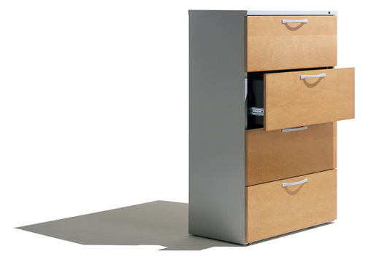

Service Description

OD4B is a personal online storage space in the cloud, provided by your organization as part of an Office 365 (O365) subscription. It can be used to store and synchronize work files across multiple devices with ease and security. Users can share their files with business colleagues as needed, and edit Office documents together in real time with Office Online. OD4B provides advantages over typical file shares in supporting versioning, sharing, co-authoring and more. Additionally, the O365 compliance tools can be used with documents in OD4B.

What is Included

- Store Work Files – Allows the copy, move, rename and deletion of files from OD4B just like other files in your file system.
- Sync OD4B – Allows access to your files from File Explorer on your desktop instead of from a web browser even when you’re not connected to the internet. All updates sync to OD4B or site libraries whenever you’re online.
- Share Documents/Folders – Allows sharing from any device by going to your O365 site in a browser.
- Using Office Online in OD4B – Allows Office documents stored in OD4B to be viewed and edited in a web browser.

Service Levels

Service level objectives are based on priority, defined by impact and urgency.

Additional Information

Information and documentation regarding the shared service is available at SP Central.

Software as a Service

PA Map Gallery

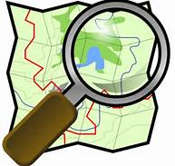

Service Description

Delivers access to and/or the creation of commonly used web maps and/or web mapping functionality.

What is Included

- Allows business partners, primarily Commonwealth agencies, local and federal government agencies, law enforcement, and first responders to gain access to commonwealth maps.
- Maps are accessible over the Internet/Intranet.
- Security – Windows authentication against active directory.
- Framework containing commonly used web mapping functionality such as zoom in, zoom out, routing/driving directions, spatial reporting, automatic vehicle tracking, map annotation, secure maps, map user management, and much more.

Service Levels

Availability Service Level Objective:
- Target 99% uptime.

Response Time Service Level Objective:
- Urgent –Production service is unavailable – Immediate.
- High – Connectivity issue or performance issue – 1 business day.
- Medium – Firewall Port to be open – 2 – 5 business days.
- Low – Questions or Informational request – 6 to 10 business days.

Additional Information

None

Software as a Service

Photo Search - Federated


Service Description

Provides photographs from Web Commonwealth Photo Imaging Network (CPIN) and PennDOT. Results include driver and offender demographic information, address information, license information, criminal case information, and physical characteristics.

What is Included

- All photos that match criteria
- Driver and/or offender demographic, physical characteristics and address information
- Driver’s license information
Criminal case information, if applicable

Service Levels

Availability of JNET applications used by Member Organizations will average greater than 98.5 % each reporting period.

Additional Information

In general, web services are used to provide the most current and accurate information available from a resource, not to populate or store information in additional databases. For this reason, photographs cannot be saved or stored.
PHOTO_ SSP_v_1.0.1
www.pajnet.pa.gov
For users with JNET accounts, https:\\www.jnet.pa.gov

Software as a Service

TomTom Tools



Service Description

Provides access to commercial map data.

What is Included

- For use by all Commonwealth government organizations, all first responders, Regional Counter Terrorism Task Forces (RCTTF), regional planning organizations, and K-12 schools and districts.
- Contractors/consultants doing work for these organizations can use the data as long as their client is one of these agencies, and it is used specifically for the specified licensee’s project.
- A letter of understanding (LOU) must be signed by all sub-license parties.

Service Levels

Service Activation:
- Completion of requests within 3 business days.

Additional Information

The components of this offering include:
- MultiNet with routing attribution, state of PA plus a county buffer of surrounding states.
- StreetMap Premium for ArcIMS and ArcGIS Server, nationwide coverage includes United States, Canada, and Puerto Rico.
- MultiNet Administrative Areas, state of PA.
- MultiNet Post (Zip+4 Centroids), state of PA.
- MultiNet FGDC Metatdata.

Software as a Service

Web Map Creation



Service Description

Provides personnel resources for the creation of web maps based on customer requirements.

What is Included

- Work with customer to define requirements such as symbology, colors, labels, etc.
- Requirement and design documents.
- Create web map using commonwealth standard tools.
- Publishing of web maps on the Internet/Intranet.
- Hardware/software infrastructure that is required for web mapping.

Service Levels

Web Map meets the business requirements and design as contained within relevant documents.

Additional Information

Requirements and design phases obtain customer signature to authorize the start of web map development.

Software as a Service

Web Map Hosting

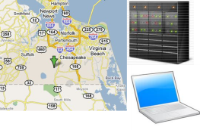

Service Description

Delivers use of hardware and geospatial software that is required to place a web map and/or web map application on the Internet/Intranet.

What is Included

- Offers shared service for use by multiple agencies.
- Uses commonwealth standard tool set of ArcGIS Server software.
- Provides a testing and robust staging and production infrastructure.

Service Levels

Availability Service Level Objective:
- Target 99% uptime.

Response Time Service Level Objective:
- Urgent –Production service is unavailable – Immediate.
- High – Connectivity issue or performance issue – 1 business day.
- Medium – Firewall Port to be open – 2 – 5 business days.
- Low – Questions or Informational request – 6 to 10 business days.

Additional Information

None

Appendix

Revision History

Date | Description | Author
10/1/2015 | Initial Draft | Jason Salvaggio
10/15/2015 | Added Daptiv & IES Business Application Services | Jason Salvaggio
3/13/2016 | Added (5) JNET Services | Jason Salvaggio

